SmartCar Mobility Ecosystem
____________________________

www.insoftdev.com
+44 (0) 2031 500 250 ; +4 (0) 724 017 764
office@insofdev.com
__________________________________________________________________________

Technology Innovation Center

Smartcar, Driver App

User Manual

Driver app is a mobile application designed to run on mobile operating systems such as Android and iOS.

INSOFTDEV SmartCar driver app is used by the drivers to accept and manage orders from your dispatcher and customer apps while enables the organizations to track and monitor in real-time the driver status and location.
“Enables startups, corporates and SMEs to launch and scale new mobility ecosystems all around the world.”
To get started using the app, it must be downloaded first from PlayStore or Appstore, with the link provided by the partner company.

For using the app, there will be required to have an account created with the partner company.

In the next page,there will be presented the applications options and will be described the booking process.

Notes:
- All below screenshots have been taken using the Demo Driver app.
- Each Driver app may have different menu options, such as Private jobs(Allow on-street jobs), Job Offers (BID, NetworkConnect).
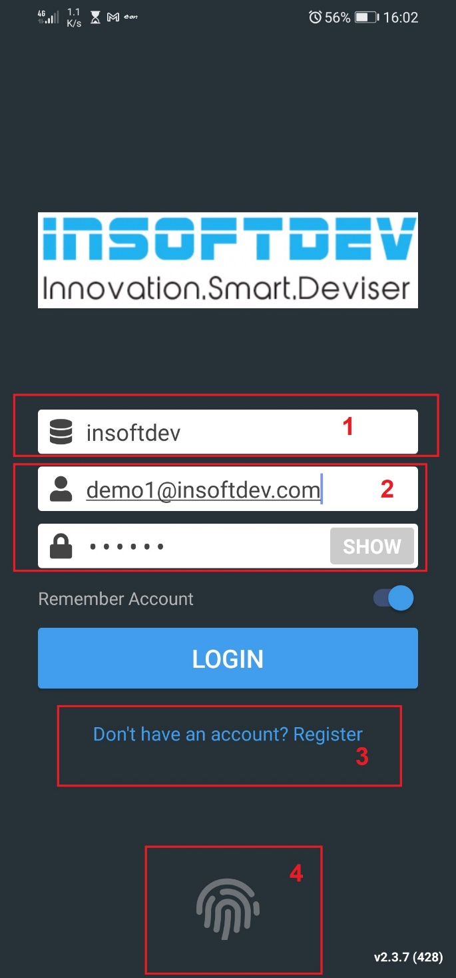
Login screen

Once the driver will be launching the app, the Login screen will show up. Authentication is mandatory.

Each Partner Driver app will display the company logo and a background chosen by the partner. Both elements can be setup from Backoffice application.

Fields:
- (1) Partner Company identifier – this identifier is provided by the company to the driver.
- (2) In order to access the app, a driver must have an account to login: the account is unique identified by his email and password.
- (3) Driver can register an account with the company by filling a form and he can add information about himself and the used vehicles, including official documents. The driver can receive jobs only after his account is reviewed by company and approved.
- (4) Finger print authentication, as alternative to Email & Password.

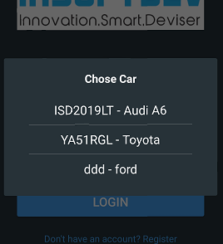
When Login button will be pressed, if the driver has more vehicles assigned, he will be asked to select the vehicle he wants to login and work with.

Notes:
If a driver has more vehicles he works with, he will be able to receive jobs for any, but when he will start the work, the app will automatically re-login with the vehicle for the booking which was last dispatched to him.

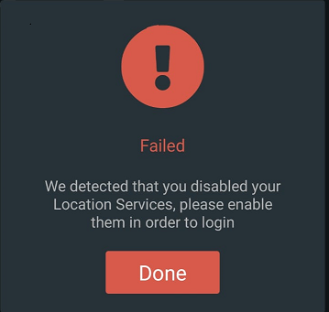
Possible issues at login
- If the vehicle is expired (has an end date before the current date), an error will be returned

- If the selected vehicle is expired, an error will be returned

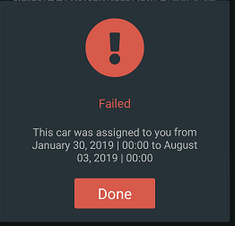
Notes:
A complete trouble-shooting document is presented in the online version here: https://insoftdev.com/knowledge-base/driver-app-troubleshooting/

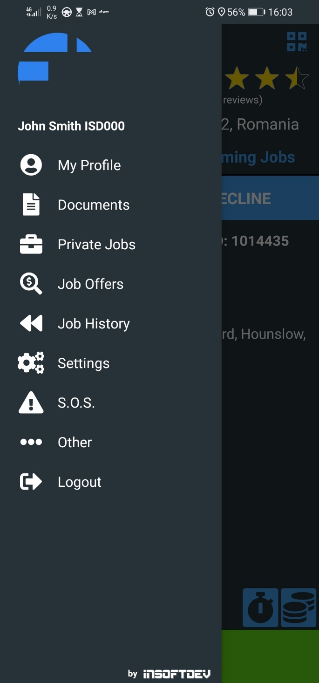
Main screen – Menu

The main screen page will be displayed after the driver successfully logs in the app.

The page includes a main menu with the company logo and a list with options as below:
- My Profile - standard: a page with the driver details such as: driver picture, current vehicle, name, email, password, address, working scheduler, earning, rating.
- Documents - standard: from this section, the driver can review and manage the account and vehicles details – identification, expiration dates, documents.
- Private jobs – optional: If enabled by the company, the driver can create and start new jobs from the app.
- Jobs Offers - optional: a page where the client can enter a voucher to receive discounts.
- Job History - standard: a page with past bookings processed by the driver
- Settings - standard: display information about the current app version, language selector, job reminder settings, preferences - layout and navigation.
- S.O.S - standard: the driver can push this button and send alert notification to Company.
- Other – Report a technical problem - standard: the driver can report any technical issue with the app from this section
- Logout – standard.

Main screen – Current job.
The main areas of this screen include:
- (1) Display the current vehicle in use and driver current location.
- (2) Display the current job.
- (3) Under Upcoming Jobs tab will be displayed all bookings which have been assigned to the driver but not yet accepted or started.
- (4) Display the current job status. This section is used by the driver to change the booking statuses;
- (5) Booking details- includes information about pickup date and time, pickup and drop off address, estimated distance and duration of the trip, client and passenger details, the vehicle which has been dispatched to it, the payment method, amount and status of it.
- (6) Documents - view any document which has been attached to current booking
- (7) Taximeter Switch mode - display more information about the booking, the map itinerary and taximeter counter (if enabled from Backoffice).
- (8) Option to add notes to the booking and passenger details.
- (9) Display the driver price for the selected booking
- (10) Start Navigator (by default the app integrates GoogleMaps and Waze).

Booking process
- The bookings can be dispatched to the driver from the Platform automatically (based on predefined dispatch rules which have been prior set by the company under Backoffice application) or manually by the operators.

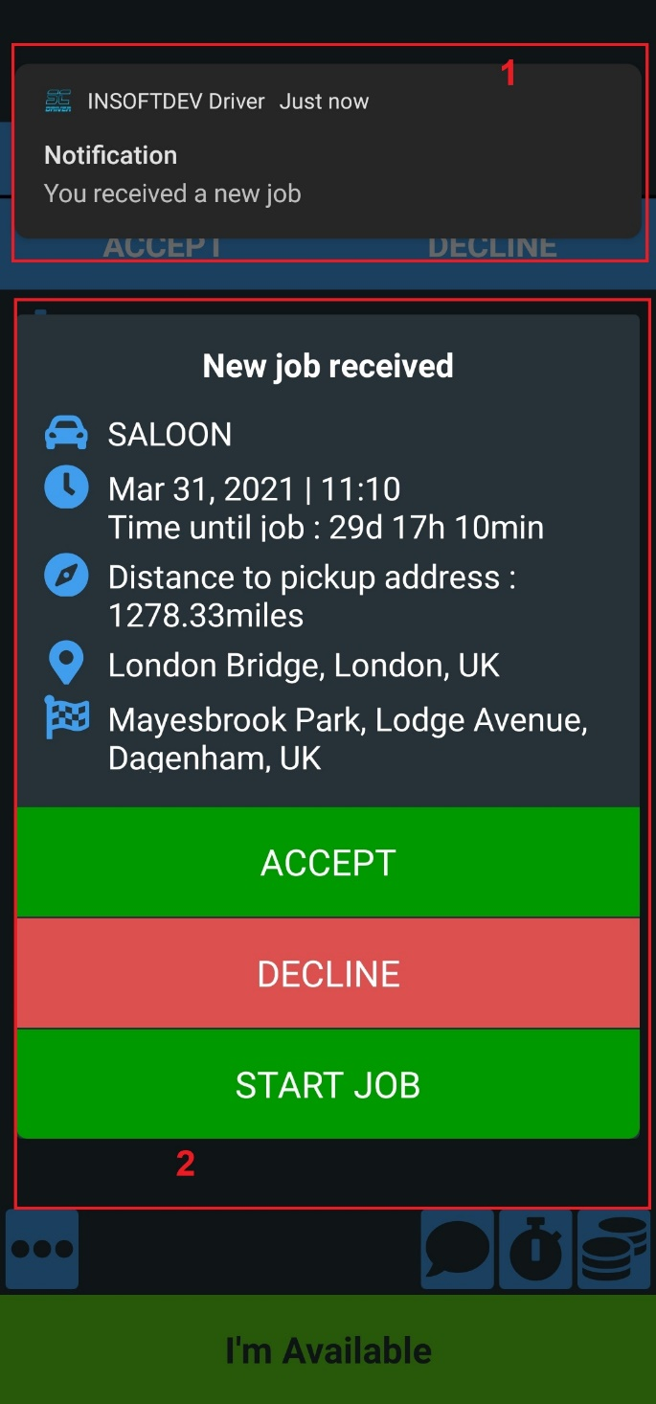
- As long as the driver is logged in the app and he is running on the device (background or foreground),when a booking will be dispatched to a driver, there are triggered next events:
          - a sound notification
          - (1) a push notification
          - (2) New job received - a pop-up window with assigned booking details (this pop-up will be displayed as soon as the app is opened in foreground).

The new job received window display:
- Booking details
- Accept option – by pressing this option, the driver accepts the booking and its status will be changed to Confirmed; the Company will be notified automatically.
- Decline – by pressing this option, the driver declines the job, and the company will be notified about the driver action automatically
- Start Job – by pressing this option, the driver will confirm and Start the job;
Note:
- At a time, only one job can be started. If a driver wants to start a job, he must finish the one in progress
- The possible statuses of a booking are: Confirmed, DOW(Driver on the way), DAP(Driver at pickup), POB(Passenger on board), Done(Completed).
Jobs History
- Job History list can be accessed from the main menu.
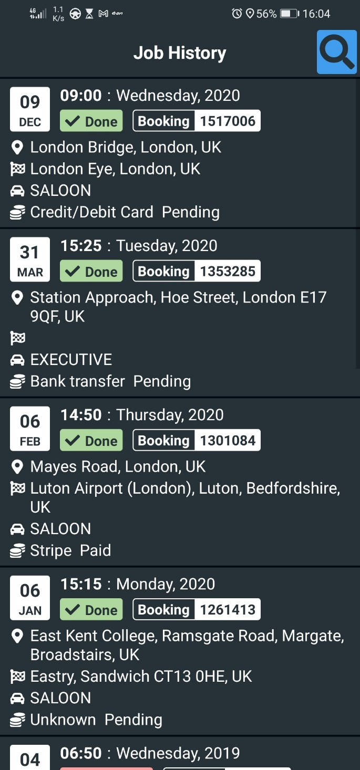
- The list will include all completed or canceled jobs for the driver on all assigned vehicles, descendant sorted.
- The list can be filtered by pickup date or booking id.

For a booking, the driver can view next information:
- booking details- by default in the main list will be displayed minimal information for a booking. By pressing on that booking, there will be displayed the complete booking details.
- Rating and comments which have been given by the client
- Earning for selected booking
- Booking recorded itinerary – map

Notes:
- The company may decide to enable from Backoffice GDPR rules , case in which the driver will not be allowed to see the client and passenger details.

Documents
- Documents section can be access from main menu and it is a dashboard from there the driver can manage the account and the assigned vehicle information.
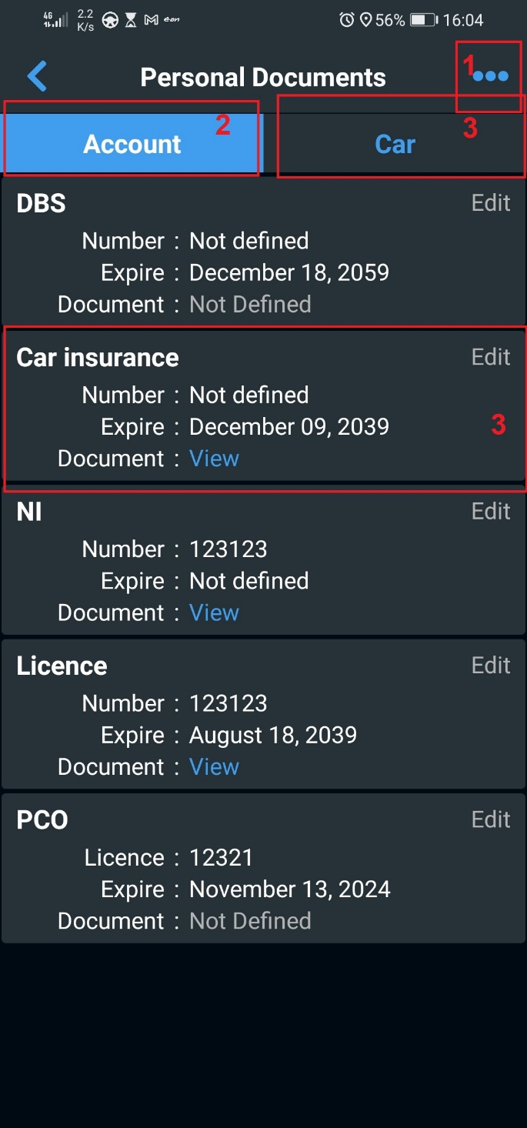
- (1) Option to view the persona documents, invoices generated on the driver’s behalf from the Backoffice and public documents.
- (2) Account section – the driver can edit specific account fields – such as driver insurance, driver license, etc. For each field there can be edited number, expiration date, update and view the evidence document
- (3) Car section – the driver can edit car details specific fields. For each field there can be edited number, expiration date, update and view the evidence document

Notes:
- All fields listed under Account and Car section are custom made and defined under Backoffice application by the company.
- A field can have up to 3 attributes: number, expiration date, document attached.
- Expiration dates are relevant and may be enabled to be used when dispatch the jobs

Thank you

INSOFTDEV Mobility

UK:
Lumina Way, Enfield, EN1 1FS, London;
+44 (0) 2031 500 250
office@insoftdev.com

RO:
Str. Ciurchi, no.81-83, 3rd Floor, Iasi
+4 (0) 724 017 764
office.ro@insoftdev.com

www.insoftdev.com

